Chatbot Workflow & Interaction Flow Document (MVP)

Table of Contents
1.Overview 2
1. High-Level Workflow 2
2. Fallback + Support Flow 5
2. Multilingual Logic 7
3. Response Behaviour Types 9
A. Greeting / Low-Intent Handling 9
B. Valid Question (Answer Found) 10
C. No Answer Found (Fallback) 11
D. Email Detection (Direct Escalation) 12
E. Context Handling (Response Behaviour Type) 15
4. Message Feedback & Escalation Flow 16
5. Email Types (Tracking Source) 19
6. Simplified Flow Tree 20
7. Example Scenarios (Use Cases) 22
1. Greeting 22
2. Short Input / Low-Intent Interaction 22
3. Valid Question (English) 22
4. Valid Question (Spanish) 23
5. Spanish Question (Fallback Mechanism -Multilingual Retrieval) 23
6. English Selected, User Types in Spanish 23
7. Spanish Selected, User Types in English 24
8. No Answer Found 24
9. Unsatisfied Feedback 24
10. Direct Support Request 24
11. Email Detection 25
12. Escalation Limit Reached 25
13. Language Switch Mid Chat 26
14. Context Follow-Up Question 27
15. Support Suggestion Trigger (Auto Escalation) 27
7. Overall, Session Rating Flow 28
8. Key Design Decisions 30
9. Overall Limitations 31
10. Notes for Future Phases 31

1.Overview
This chatbot is designed to:
- Answer user questions using a knowledge base (RAG)
- Support English and Spanish
- Handle greetings, small talk, and context questions
- Avoid hallucination (only answers from KB)
- Provide human escalation via email
- Track session and user behaviour
The system ensures:
- Accurate responses
- Controlled fallback
Note
This document focuses on high-level system behaviour and user interaction flow.
Technical implementation details (such as algorithms, preprocessing steps, and system architecture) are intentionally excluded to provide a clear understanding of how the system behaves from a user perspective.

1. High-Level Workflow
User Message
↓
Language Detection / Selected UI Language
↓
Input Processing (Normalization)
↓
Check: Greeting / Low Intent?
↓ YES → Respond directly (no RAG)
↓ NO
Retrieve from Knowledge Base (Primary Language)
↓
Relevant Answer Found?
↓ YES → Return Answer
↓ NO
Try Fallback Language Retrieval (EN ↔ ES)
↓
Relevant Answer Found?
↓ YES → Translate → Return Answer
↓ NO
Trigger Fallback Response + Support Option(email window)

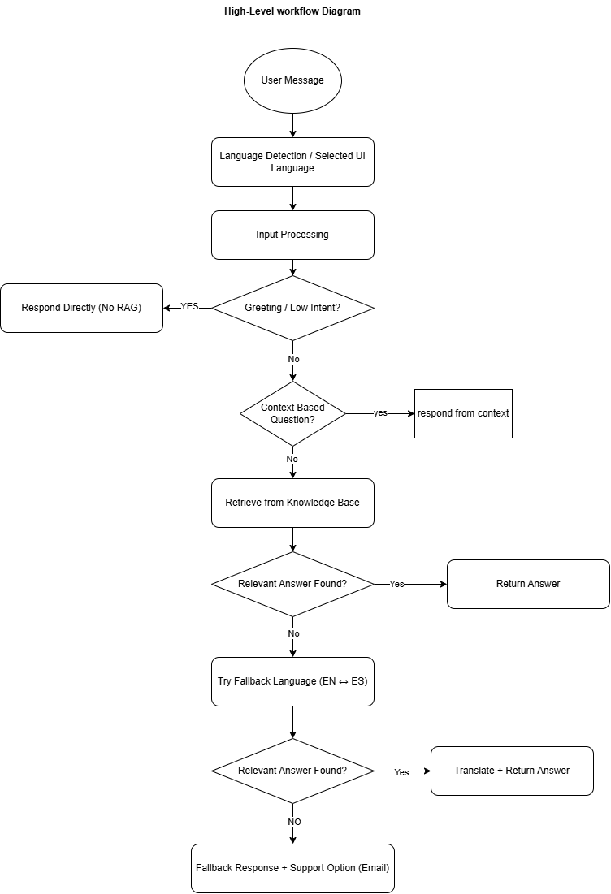

2. Fallback + Support Flow

No Relevant Answer Found
↓
Show Fallback Message
("I couldn’t find a relevant answer, please contact our support team for future assistant")
↓
Show Support Option
↓
Open Email Window (Popup)
↓
User enters Email + Comment
↓
Submit Support Request
↓
Save Ticket (Fallback Escalation)
↓
Show Confirmation Message (succuss message)
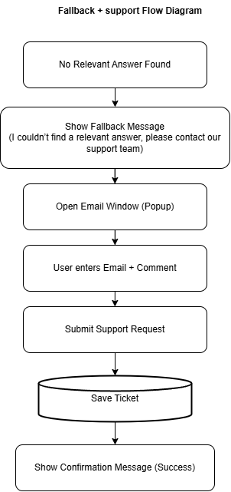

2. Multilingual Logic
Language Selection:
• Users can select their preferred language:
English (EN)
Spanish (ES)

System Behaviour:
• The system always prioritises the selected language
• When a user asks a question:
It first searches the Knowledge Base in the selected language
If a relevant answer is not found → it automatically retries using the alternate language
• If an answer is found in the fallback language:
The system converts/translates the response
The final answer is always shown in the user’s selected language
Key Points:
• Users can type in supported languages:
Users can type in English or Spanish, regardless of the selected language
• The system ensures:
- Consistent user experience
- Responses always match the selected language
• Language can be changed at any time during the chat:
- New responses follow the updated language
- Conversation continues without interruption

Limitations:
• The system currently supports English and Spanish only
• Inputs in other languages (e.g., French, Sinhala, Tamil, etc.) are not fully supported
• Such inputs may:
- Fail to retrieve relevant results
- Trigger fallback response unnecessarily

Example:
• User selects: Spanish
• User types: “How do I reset my password?”
→ System retrieves answer (English KB)
→ Converts response
→ Displays answer in Spanish
Notes:
• This approach improves accessibility for multilingual users
• Ensures users receive answers even if content is available in only one language

3. Response Behaviour Types
A. Greeting / Low-Intent Handling
Handles simple user inputs such as greetings or non-informational messages (e.g., “Hi”, “Hello”), responding directly without retrieving from the knowledge base.
Examples:
• “Hi”
• “Hello”
• “Hey”
• “Good morning”
• “Good afternoon”
• “Good evening”
• “Thanks”
• “Thank you”
• “Ok” / “Okay”

Behaviour:
• Message is normalized (lowercase, trimmed)
• Checked against predefined keyword list
• If matched:
- Direct response returned
- KB retrieval (RAG) is skipped
- No feedback buttons shown
- No escalation triggered

Limitations:
• Depends on exact keyword matching (no semantic understanding)
• Variations like:“heyyy”, “hii”, “gud morning” may not be detected
• Mixed messages (e.g., “hi I need help”) will bypass this and go to RAG
• Requires manual updates to support more phrases/languages
• Not scalable for real-world intent detection (rule-based only)

B. Valid Question (Answer Found)
Behaviour:
• User query is processed and passed to the retrieval pipeline
• System searches the Knowledge Base (ChromaDB) using embeddings
• Most relevant chunks are retrieved based on similarity threshold
• If relevant answer is found:
- Response is generated using retrieved context (RAG)
- Final answer is returned in the selected UI language
- Context is stored in session (Redis) for continuity
• UI Actions:
- 👍 Satisfied
- 👎 Not Satisfied
• Feedback Handling:
- 👍 Satisfied → store feedback in database
- 👎 Not Satisfied → trigger escalation flow (email support, based on limits)
Additional Behaviours:
• Multilingual handling:
- Retrieval is first attempted in selected language
- If needed, fallback language may be used (EN ↔ ES)
- Final response always shown in selected language
Limitations
- The system responses depend on the content available in the Knowledge Base. If information is not present, the system will guide users to contact support instead of generating assumptions.
- The quality of answers may vary based on how well the uploaded documents are structured and maintained.
- Multilingual support is available; however, performance may vary if content is primarily available in one language.
- The system is designed to prioritise accuracy over guessing, so in some cases it may not provide an answer even if a partial match exists.
- Certain user inputs (e.g., combined greetings with complex queries or unclear phrasing) may affect how the system interprets the request.

C. No Answer Found (Fallback)
Behaviour:
• If the system cannot find a relevant answer in the Knowledge Base, it will not attempt to guess or generate an uncertain response
• Instead, it shows a clear fallback message:
“I couldn’t find a relevant answer to your question. Your enquiry can be forwarded to our support team.”
Support Option:
• Users are given the option to contact support
• If allowed:
- A Contact Support option is shown
- An email popup is provided for submitting the request
• If the user has already contacted support:
A confirmation message is shown before allowing another request:
“You have already contacted our support team. Do you want to contact them again?”
Buttons:
• Yes → opens email popup
• No → continue chat
• If the request limit is reached:
The system asks the user to wait for a response from the support team
“You have reached the maximum number of support requests for this session. Please wait for our team to respond.”

D. Email Detection (Direct Escalation)
User Message
↓
Check: Email Detected? (e.g., example@gmail.com)
↓ YES
Validate Email Format
↓
Valid Email?
↓ NO → Show "Invalid Email" Message

↓ YES
Check Support Request Count (Session)
↓
First Time Request?
↓ YES
Open Email Window (Prefilled)
↓
User adds Comment
↓
Submit Support Request
↓
Save Ticket (Direct Escalation)
↓
Show Confirmation Message

↓ NO (Already Submitted Before)
Ask Confirmation:
"Do you want to contact support again?"
↓
User selects YES
↓
Check Limit Exceeded?
↓ NO
Open Email Window (Prefilled)
↓
Submit Request → Save Ticket

↓ YES (Limit Exceeded)
Show Message:
"You have reached the maximum support requests. Please wait for assistance."

↓ User selects NO
Continue Chat (No Escalation)

↓ NO (No Email Detected)
Continue Normal Chat Flow (Diagram 1)
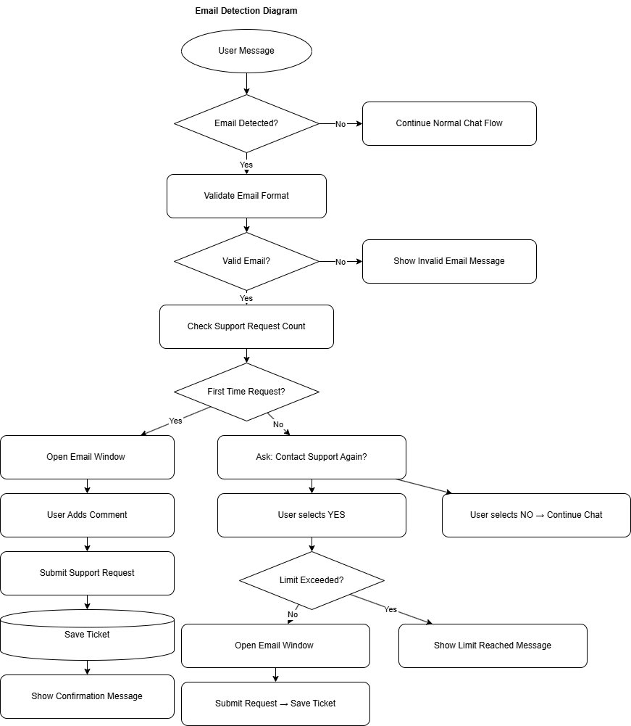
If user types:
- “I need support”
- “Contact staff”
- Or enters email
Behavior:
- Open email popup directly
- Prefill email if detected

E. Context Handling (Response Behaviour Type)
The system supports context-aware interactions by maintaining conversation history within the session.
System Behaviour:
- The system remembers relevant information shared earlier in the conversation
- Follow-up questions are interpreted based on previous messages
- The system can provide answers using stored session context (without relying on the knowledge base)
Example:
User: My name is John
User: What is my name?
Response: “Your name is John.”

User: I am unable to log into my account
User: What did I just say?
Response: “You said “I am unable to log into my account.”

Additional Behaviour:
- If the required context is not available, the system responds appropriately (e.g., “I don’t have your name yet.”)
- Context is maintained throughout the active session
- Context may expire or reset after session timeout or configuration rules (30 minutes)

Limitation:
- Previous chat messages remain in their original language when the user switches language during the session
- Context handling is better for simple follow-up questions (e.g., recalling a name or recent message) than for complex reasoning across long conversations

4. Message Feedback & Escalation Flow
👍 Satisfied
• Feedback is recorded and stored in DB for analysis
• A short confirmation message may be shown to the user (e.g., “Thank you for your feedback”)
• Chat continues normally without any interruption

👎 Not Satisfied
• Feedback is recorded and stored in DB for analysis
• The system checks how many times the user has already requested human support within the session

If support request count < =2:
- An email popup is shown to contact support
User can:
- Enter or confirm their email address
- Add additional comments (optional)
Once submitted:
- The support request is saved in the database (including user query, chatbot response, and summary)
- The request is sent to the support team
- The support request count is updated for the session
If support request count > 2:
• The system does not open the email popup
• Instead, it shows a message:
“You have already contacted support. Please wait for assistance.”
• Chat can continue, but additional support requests are restricted
Additional Notes:
• This flow ensures users can easily escalate issues when needed
• At the same time, it prevents multiple duplicate requests within a single session
• All support requests include relevant context to help the support team respond effectively
Unsatisfied Flow
User clicks 👎 Not Satisfied
↓
Check Support Request Count (Session)
↓
First Time Request?
↓ YES
Open Email Window
↓
User enters Email + Comment
↓
Submit Support Request
↓
Save Ticket (Unsatisfied Escalation)
↓
Show Confirmation Message

↓ NO (Already Submitted Before)

Ask Confirmation:
"Do you want to contact support again?"
↓
User selects YES
↓
Check Limit Exceeded?
↓ NO
Open Email Window
↓
Submit Request → Save Ticket

↓ YES (Limit Exceeded)
Show Message:
"You’ve already contacted support. Please wait for assistance."

↓ User selects NO
Continue Chat (No Escalation)
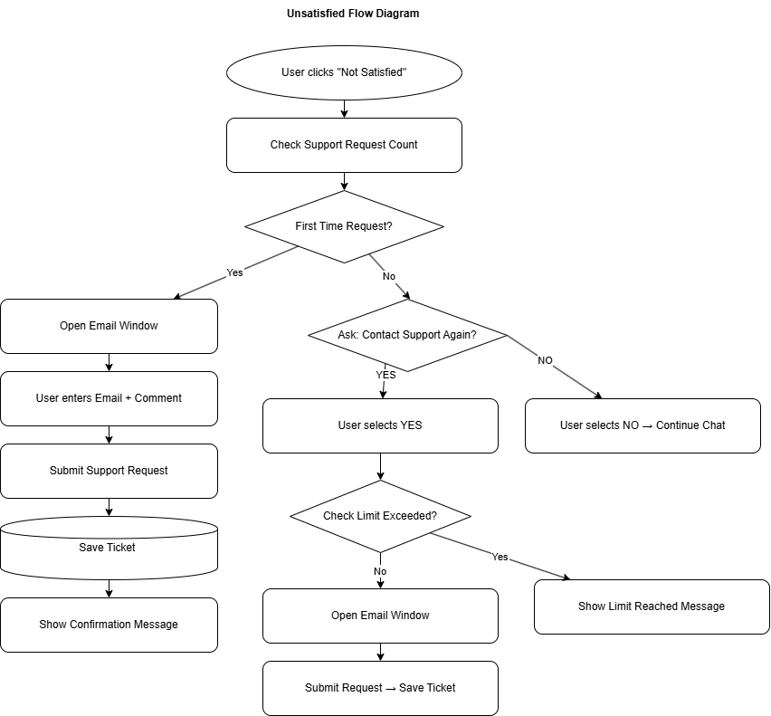

Re-contact Flow
If already escalated:
- Ask:
“Do you want to contact support again?”
Options:
- Yes → Open popup (max 2 total)
- No → Continue chat

5. Email Types (Tracking Source)
To support monitoring and analysis of support requests, each email escalation is tagged with a specific source type.
This source is stored in the database to identify how the escalation was triggered
Scenario | Source
Fallback triggered | fallback_escalation
User clicks unsatisfied | unsatisfied_escalation
Bot suggests support | direct_escalation
User types of email | user_direct_request

6. Simplified Flow Tree
User Message
│
├── Greeting? /Short talk
│ └── Yes → Respond → END
│
├── Retrieve Session Context
│
├── Retrieve from Knowledge Base
│
├── KB Answer Found?
│ └── Yes → Show Answer + Feedback
│
├── Try Fallback Language?
│ └── Yes → Answer Found?
│ └── Yes → Translate + Respond
│
└── No Answer
└── Show Fallback + Support Option
├── Email Entered → Send Email
└── Unsatisfied → Open Email Popup
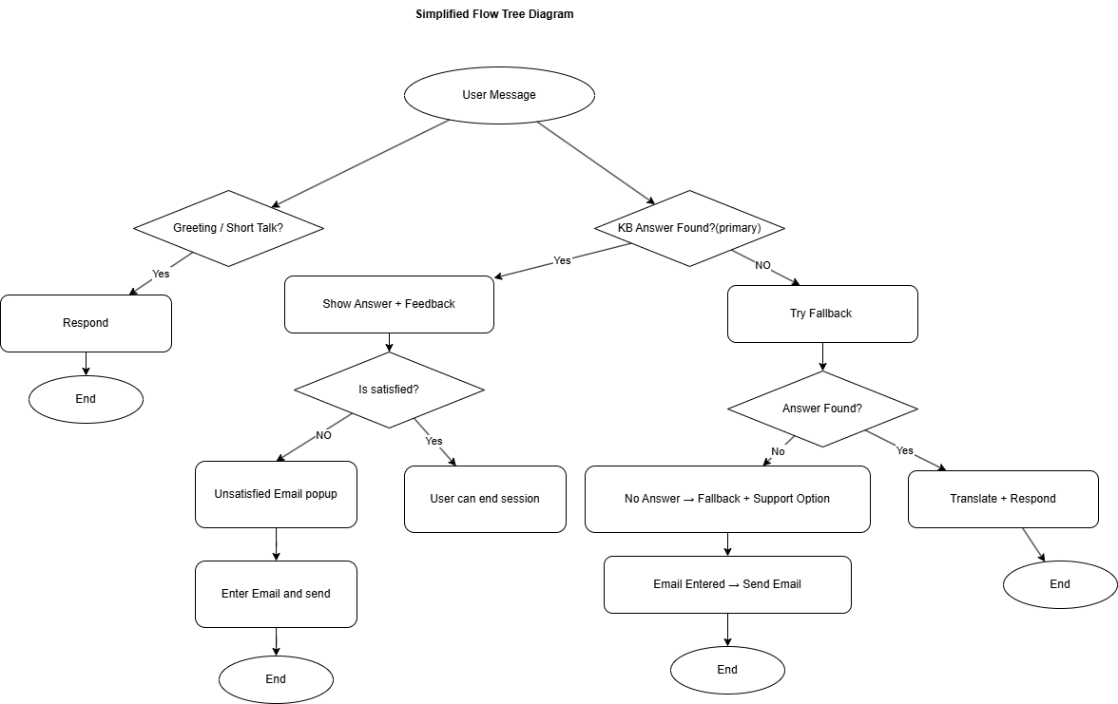

7. Example Scenarios (Use Cases)

1. Greeting
User: Good morning!
Expected Behaviour:
- The system responds with a greeting (e.g., “Good morning ! How can I help you today?”)
- No feedback options are displayed
- No knowledge base retrieval is triggered

2. Short Input / Low-Intent Interaction
User: ok / thanks/hm/mm
Expected Behaviour:
- The system recognises the input as a short or low-intent message
- A simple acknowledgement response is generated based on the existing predefined replies
  - Example: “You’re welcome! Let me know if you need anything else.”
- No knowledge base retrieval is performed
- No feedback or support options are displayed
- No email escalation is triggered
- No source is recorded in the database

3. Valid Question (English)
User: How do I reset my password?
Selected Language: English
Knowledge Base:
Currently contains primarily English content (Spanish doc may be added later)
Expected Behaviour:
- The system retrieves the correct answer from the knowledge base
- The response is shown in English
- Feedback options (👍 / 👎) are displayed

4. Valid Question (Spanish)
User: ¿Cómo accedo a mi curso?
Selected Language: Spanish
Knowledge Base:
Currently contains primarily English content (Spanish doc may be added later)
Expected Behaviour:
- The system retrieves the answer
- The final response is shown in Spanish
- Feedback options are displayed

5. Spanish Question (Fallback Mechanism -Multilingual Retrieval)
User: ¿Cómo accedo a mi curso?
Selected Language: Spanish
Knowledge Base:
Currently contains primarily English content (Spanish doc may be added later)
Expected Behaviour:
- The system first attempts retrieval using the Spanish query
- If no relevant result is found, the query is translated into English
- The system performs retrieval again using the English query
- The retrieved answer is translated back into Spanish
- The final response is shown in Spanish

6. English Selected, User Types in Spanish
User: ¿Cómo restablezco mi contraseña?
Selected Language: English
Expected Behaviour:
- The system processes the Spanish input
- Retrieves the relevant answer (via multilingual handling)
- The final response is generated in English (selected language)
- Feedback options (👍 / 👎) are displayed

7. Spanish Selected, User Types in English
User: How do I reset my password?
Selected Language: Spanish
Expected Behaviour:
- The system processes the English input
- Retrieves the relevant answer from the knowledge base
- The final response is translated into Spanish
- Feedback options (👍 / 👎) are displayed

8. No Answer Found
User: Random unsupported question
Expected Behaviour:
- The system does not generate an answer if no relevant information is found in the knowledge base
- A fallback message is displayed to inform the user that no answer is available
- Support options are provided (e.g., contact support via email)

9. Unsatisfied Feedback
User Action: Clicks 👎
Expected Behaviour:
- The system opens the email support popup
- The user can submit a support request for further assistance

10. Direct Support Request
User: “I need human support”/ “I need to contact human”
Expected Behaviour:
- The system immediately opens the email support popup
- No additional steps are required

11. Email Detection
User: contact me at test@gmail.com
Expected Behaviour:
The system detects a valid email address in the user message
The system checks the current support request count for the session
If within allowed limit:
On the first request:
- The email support popup opens automatically
- The detected email is prefilled in the form
- On a repeated request (e.g., second time):
- A confirmation message is shown (e.g., “You have already contacted support. Do you want to contact again?”)
- If the user confirms, the email popup opens
- The submit button label changes to “Contact Again”
If limit exceeded:
- The system does not open the email popup
- A message is displayed:
- “You have reached the maximum number of support requests. Please wait — our team will contact you soon.”

12. Escalation Limit Reached
Scenario: User attempts to request support multiple times (e.g., third attempt)
Expected Behaviour:
- The system does not open the email popup
- A message is displayed:
“You have reached the maximum number of support requests. Please wait — our team will contact you soon.”

13. Language Switch Mid Chat
Scenario:
User changes the selected UI language during an ongoing conversation (e.g., English → Spanish or Spanish → English)
Expected Behaviour:
- All new responses are generated in the newly selected language
- Previous messages remain unchanged (no retroactive translation)
- Conversation context is preserved:
    - The system continues using prior chat history for better understanding
    - No loss of session data (Redis context remains active)
- If configured, the system may reset context when switching language (optional behaviour for strict language isolation)
System Logic:
- Update selected_language in session state
- Continue retrieval using:
Primary: selected language
Fallback: alternate language (EN ↔ ES)
- Ensure final response is always in the currently selected language
Key Points:
- Smooth user experience without restarting the chat
- Language switch does not interrupt the conversation flow
- Works seamlessly with multilingual fallback logic

User Input | Selected Language | System Behaviour
English | Spanish | Translate → Respond in Spanish
Spanish | English | Translate → Respond in English
Spanish | Spanish | Respond in Spanish
English | English | English

14. Context Follow-Up Question
Scenario: User asks a follow-up question based on previous conversation
Example Flow:
User: My name is John
User: What is my name?
Expected Behaviour:
The system remembers information shared earlier in the session
The system uses conversation context to understand the follow-up question
The correct response is generated using stored session data
Example: “Your name is John.”
No knowledge base retrieval is required for this response

15. Support Suggestion Trigger (Auto Escalation)
Scenario: The chatbot response contains support-related keywords (e.g., “contact support”, “reach out to our team”)
Expected Behaviour:
- The system detects support-related keywords in the chatbot response
- The email support popup is triggered automatically
- The user is prompted to submit a support request without additional actions
- The escalation is recorded with source type: direct_escalation

7. Overall, Session Rating Flow
After the chatbot provides a response, the system evaluates whether the response qualifies for session rating.
Flow:
Bot sends a meaningful response
↓
Check if response is:
- not a fallback response
- not a support/escalation response
- not a greeting / low-intent response
↓
If meaningful → Increase overall response count
↓
Check Overall Rating Interval
(currently every 3 meaningful bot responses)
↓
Reached interval?
↓ YES → Show Overall Session Rating Popup
↓ NO → Continue Normal Chat

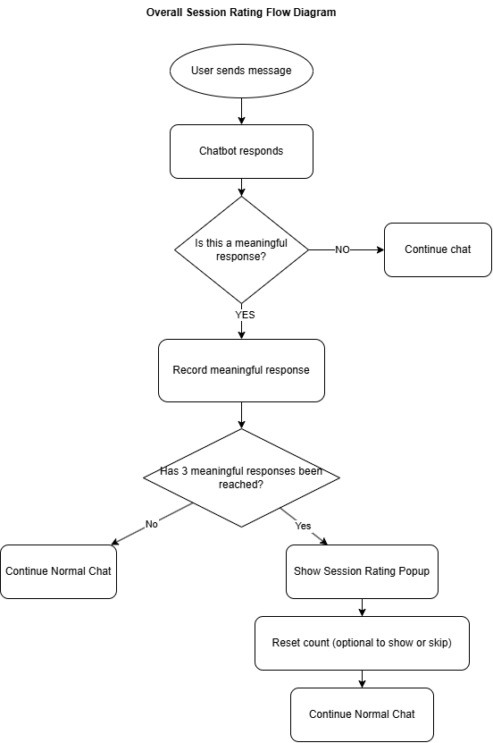

8. Key Design Decisions
The following key decisions were made during the design of the chatbot system:
- The system uses a knowledge base–driven approach (RAG) to ensure accurate and controlled responses
- The chatbot avoids hallucinations by responding only with information retrieved from the knowledge base
- A multilingual strategy (English ↔ Spanish) is implemented using a fallback mechanism rather than maintaining fully duplicated content
- Session-based context handling is used to maintain conversation continuity within an active session
- Context is stored temporarily and is not persisted long-term to ensure simplicity and performance
- Email-based escalation is used as the primary human support mechanism
- A limit is applied to support requests per session to prevent repeated or spam submissions
- Feedback (👍 / 👎) is used to capture user satisfaction and trigger escalation when needed
- All interaction data (e.g., sessions, messages, feedback, and support requests) is stored in PostgreSQL for persistence and analysis
Note: A separate database design and schema document is maintained to describe the data structure in detail

9. Overall Limitations
The current system has the following limitations:
- The chatbot relies on the available knowledge base, so it cannot answer questions outside the provided content
- Multilingual support is currently limited and depends on fallback mechanisms rather than a fully multilingual knowledge base
- Context handling is limited to short-term session memory and may not support complex or long conversations
- Spelling and grammar variations are only partially handled, and the system may not correctly interpret heavily misspelled or unclear inputs
- The system may not fully understand complex or ambiguous user queries
- Support escalation is limited per session to prevent excessive requests
- The chatbot does not include advanced personalisation features (e.g., user-specific data) in the current phase

10. Notes for Future Phases
- Add Spanish knowledge base content to improve multilingual retrieval accuracy
- Implement authentication (e.g., JWT) to enable personalised responses
- Integrate with the GetMee backend for real-time data access
- Enhance analytics and reporting for better insights
- Improve support for handling multiple language inputs within the same conversation
- Improve context handling to better manage longer conversations and more complex follow-up questions

